Git Challenge Task

- Resolve Merge Conflicts
  - Create a merge conflict intentionally (two users editing the same line).
  - Resolve the conflict and push the changes.
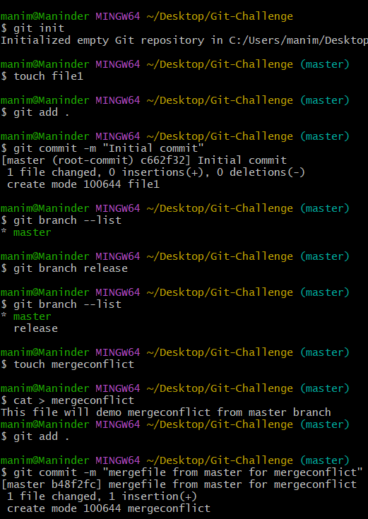
I have create a new branch from the master branch after the initial commit in the master branch and executed the command ‘git branch release’ to create a new branch.
In the master branch I have created a file name “mergeconflict’ and inserted the text inside the file. Moved the file to staging and committed the file,
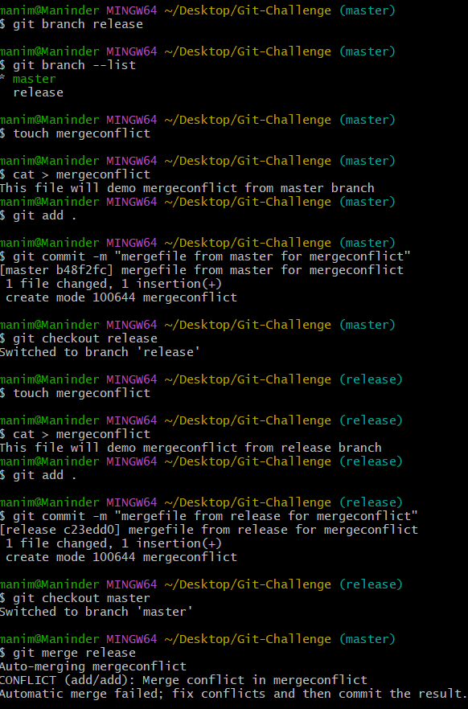
Switched to the release branch and created a file name ‘mergeconflict’ and inserted the text, staged and committed the file in the release branch
Now moved to the master branch and executed the command ‘git merge release’. Now I encountered error merge conflict in the file,
I have checked the status and found I got unmerged paths.
Checked the file and found the contents placed next to one another, made the necessary content changes to reflect in the file in the master and staged and commited the file.
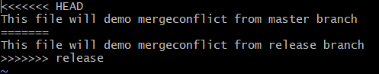

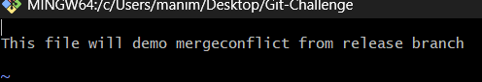
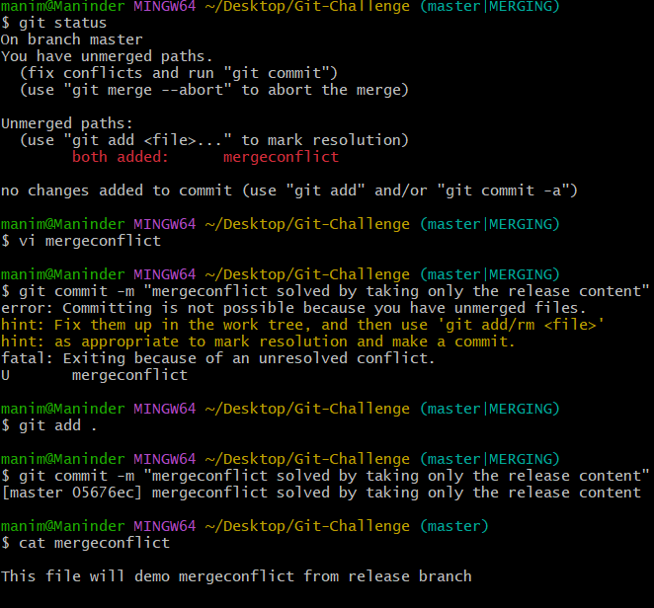
- Recover Deleted Branch
  - Delete a local branch and then recover it using the reflog.
Created a new branch from the master branch called ‘hotfix-restored’, checkout to ‘hotfix-restored’ and created a file ‘hotfixrstorefile’, stagged the file and committed the file in the ‘hotfix-restored’ branch.
Verified the commit using git log
Executed git log -1 to see if the commit history is also merged to the master branch and we can see that commit history is not copied from the hotfix-restored’
Deleted the hotfix-restored branch from the master branch using the command ‘git branch -D hotfix-restored’
Now executed ‘git reflog’ which allow us to recover from mistakes like accidental resets, rebases, or branch deletions.
This command is able to recover the commits inside the deleted hotfix-restored branch and we can see the commit id of the last commit of that particular branch
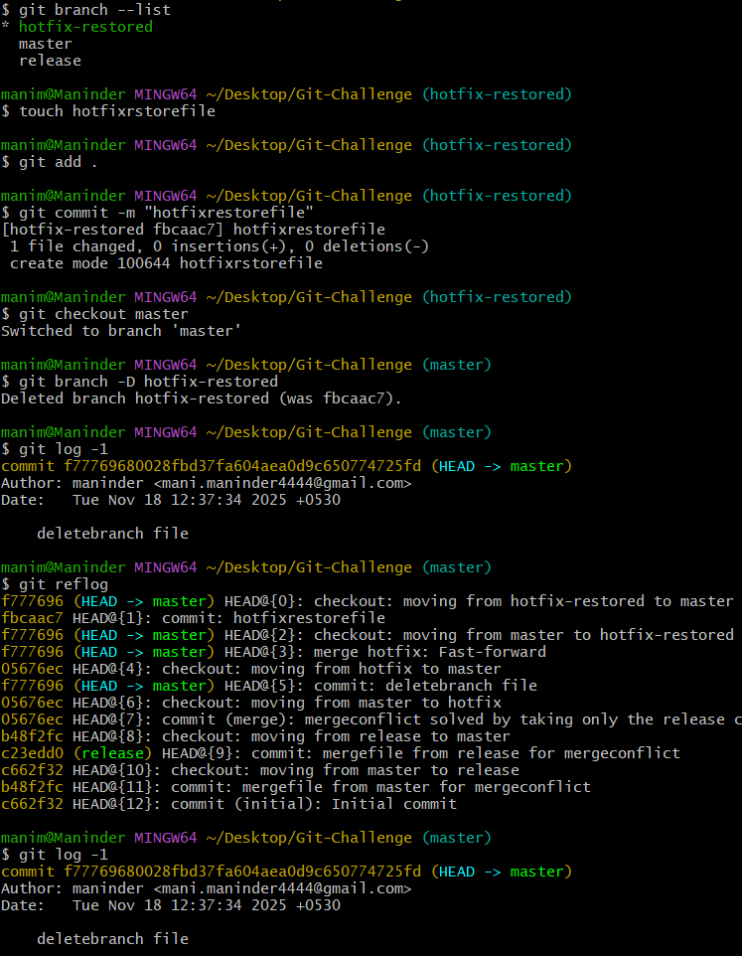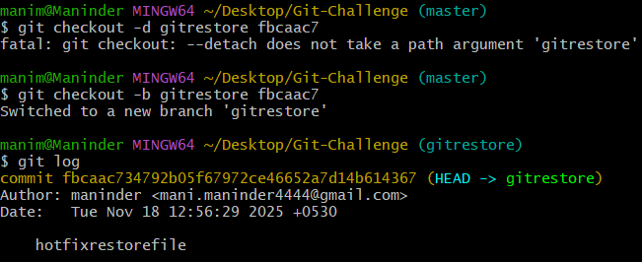
Now executed the ‘git checkout -b gitrestore <last commit id copied from gitreflog output >’ to copy the commit history to the newly created branch
We can see the commit history from the deleted branch into the newly created branch.
- Undo Wrong Push
  - Push a wrong commit to GitHub, then undo it without losing history. 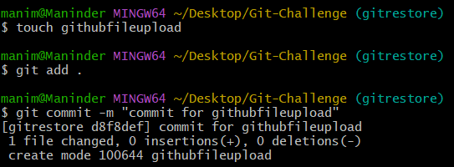
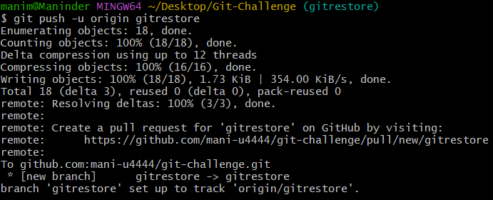
In the gitrestore branch I have created a file called githubfileupload, stagged and committed the file. Now I have pushed the code to the github using the command ‘git push -u origin gitrestore’ to gitrestore branch on the github.
Now I have reverted the commit that I done for githubfileupload using the command ‘ git revert <commit id >
The commit history now contains the history of the commit.
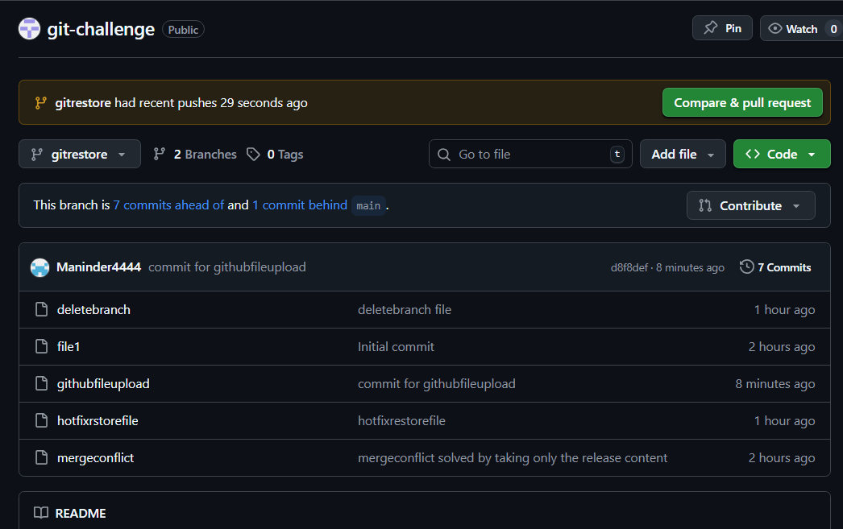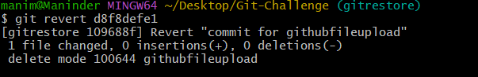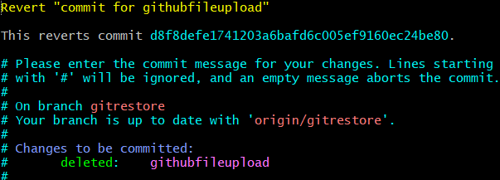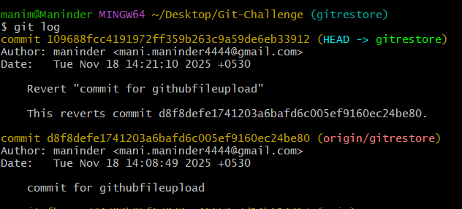

- Amend a Commit
  - Make a commit, then add a missing file to it using git commit --amend.
Created file1 with input “Content for file1”, added to stage and committed with message ‘Initial commit with file1”
Now created a file named ‘missing_file.txt” with input inside “content for the missing file” added to the staged
Now we can able to add the file from the staging to the already commited commit using the command “git commit –amend”
Changed the commit message and we can see the changes 2 files changed and see the commit details using ‘git log’
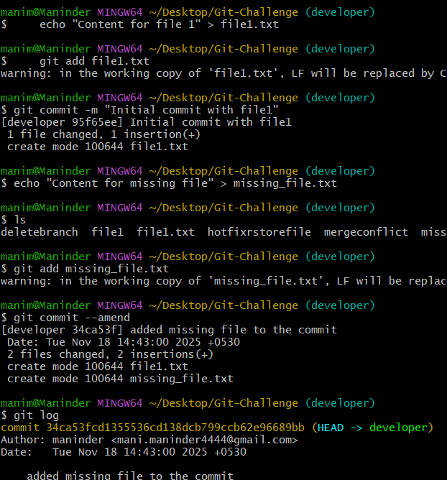

Command used;
git branch –list
git branch developer
git checkout developer
echo "Content for file 1" > file1.txt
git add file1.txt
git commit -m "Initial commit with file1"
echo "Content for missing file" > missing_file.txt
git add missing_file.txt
git commit –amend
git log
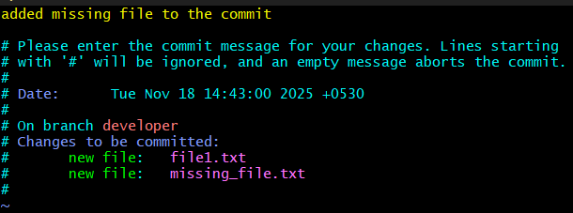

- Cherry-pick a Commit
  - Take a specific commit from one branch and apply it to another branch.
I have created a file named “cherry-pick-dev” and staged and committed (copied the id)
Checkout to release branch and executed git cherry-pick <commit_id>

Commands:

git branch –list
touch cherry-pick-dev
git add cherry-pick-dev
git commit -m " cherrypick file from developer"
git log -1
git checkout release
git cherry-pick 0a7f703c

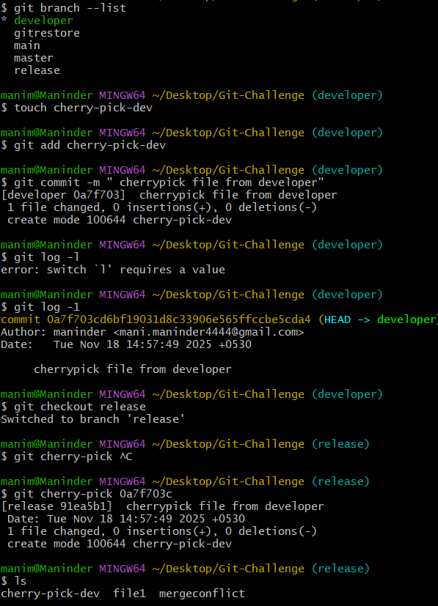

- Interactive Rebase
  - Reorder and squash multiple commits into a single clean commit.
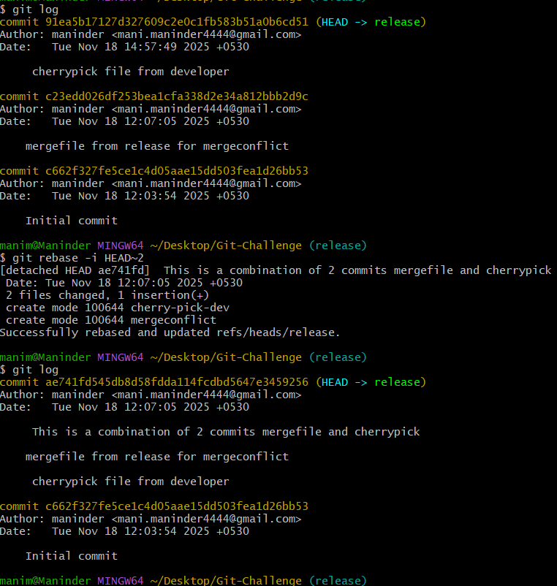

Commands executed:
Git log
Git rebase -i HEAD~2
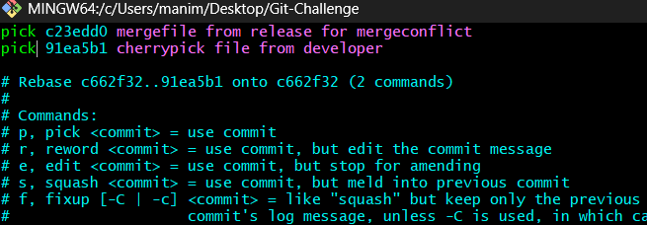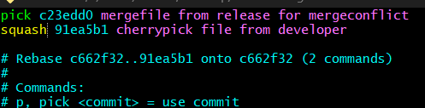

- Tagging & Release
  - Create a version tag (v1.0), push it to GitHub, then delete and restore it.
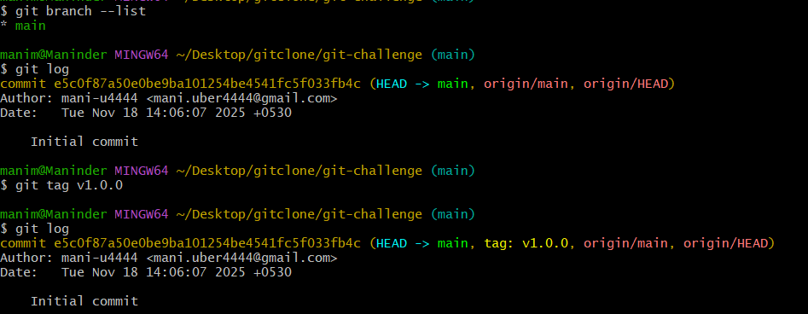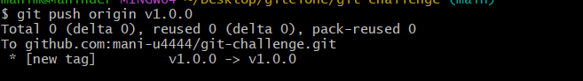
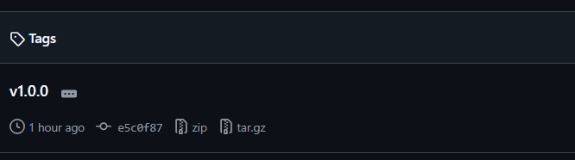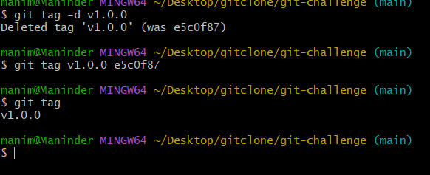
I created a tag with the command git tag v1.0.0 and pushed it. Later, I deleted the tag using git tag -d v1.0.0. Afterward, I copied the commit ID, and restored the tag with git tag v1.0.0 <commit-id>. Finally, I verified the tag by executing git tag.

- Clone with Sparse Checkout
  - Clone only a subdirectory of a repo using sparse checkout.
Git sparse-checkout is a feature that allows us to check out a subset of files or directories from a repository, rather than the entire project.

I have cloned the repository using the command git clone --no-checkout git@github.com:mujahed1716/git-challenge.git
git sparse-checkout init will activate sparse checkout mode, telling Git that you only want to download specific files or folders, rather than the entire repository.
git sparse-checkout set git-challenge will specify the folder (git-challenge) only the contents of this folder will be downloaded, rather than the whole repository.
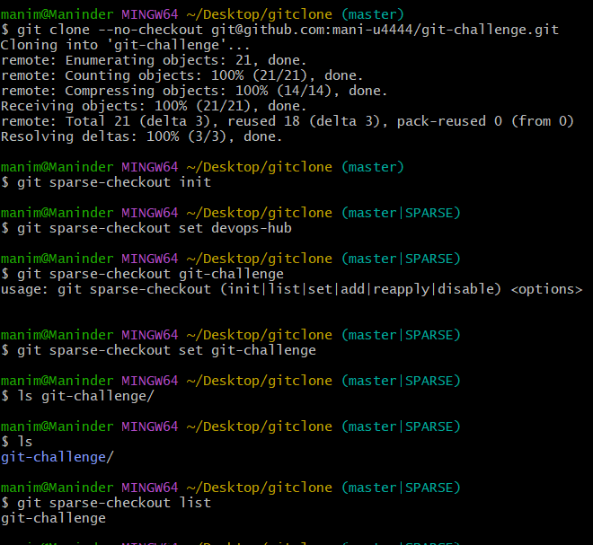

- Reset vs Revert Challenge
  - Demonstrate the difference between git reset --hard and git revert in a repo.
Git reset –hard is used to undo commits and reset the working directory and the index (staging area) to match the given commit. It can be used to remove commits from history, which means that changes made in those commits are lost unless they are saved elsewhere.
Git revert is used to undo the effects of a commit by creating a new commit that reverses the changes made by the original commit. This is useful when you want to keep the history intact but negate the changes made by a specific commit. Use it when you need to undo a commit but keep the project history intact,

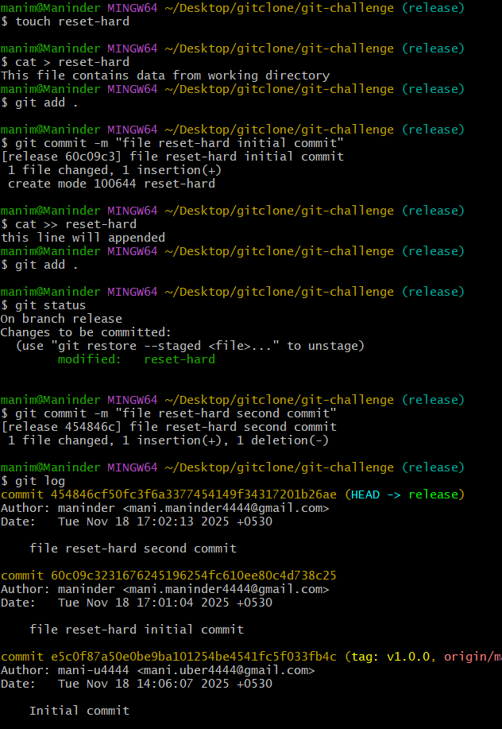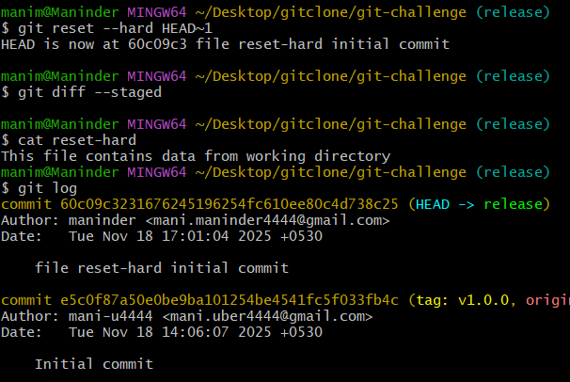

Git revert
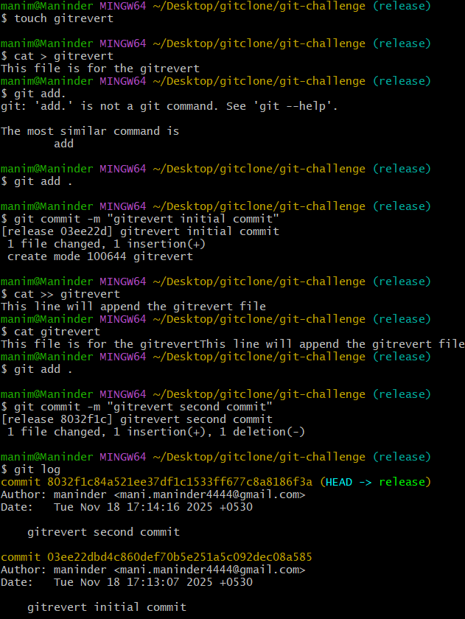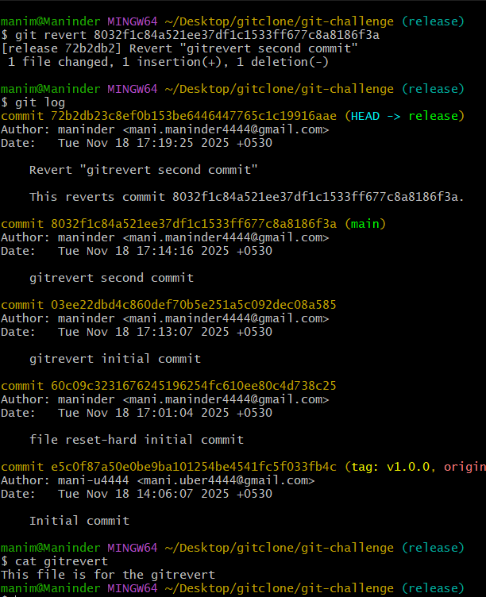

- Detached HEAD Challenge
  - Checkout a specific commit (detached HEAD state) and create a new branch from it.
Executed ‘git log –oneline’ and we can see the commit history in line-by-line. I choose the commit o3ee22d which contained the gitrevert initial commit ,
I have executed git checkout 03ee22d so that HEAD is now at the commit instead of HEAD pointed to 72b2db2 as shown in the image below.
Now named the new branch named ‘files-before-gitrevert’ for that I have executed git checkout -b files-before-revert
On executing ‘git branch –list’ we can see the newly created branch.
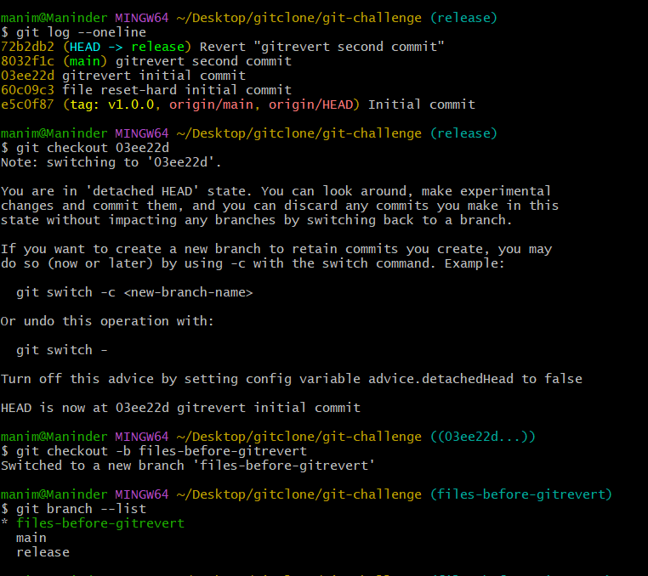

- Git Hooks Challenge
  - Configure a pre-commit hook to reject commits without a message format (e.g., must start with JIRA-XXX).

- Squash Merge vs Rebase Merge
  - Show the difference between squash merge and rebase merge with evidence.
Squash merge combines all the commits from a feature branch into a single commit before merging it into the target branch (main or master). It's useful when you want to maintain a cleaner history in the target branch.
Rebase merge involves taking the changes from a feature branch and replaying them on top of the target branch (often main or develop), essentially moving the base of your branch forward. It's useful for keeping a cleaner, more linear history in the project, without unnecessary merge commits, while preserving the full commit history from the feature branch.

Implementation (Squash merge) : I have created two files file11 and file22, both stagged and committed, the commit history is of the following as shown in the image1. now I went to the main branch and executed the command ‘git merge –squash <branch name> , I have committed the squashed commits to the new commit name “squash from newbranch”.
The git log command shows the committed commit on the top along the old commits.

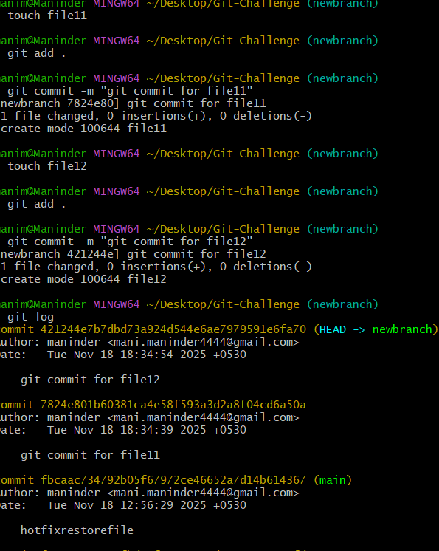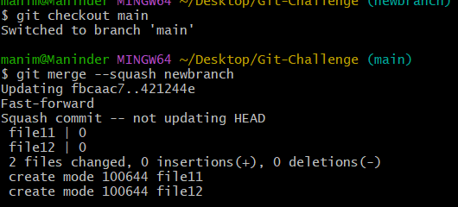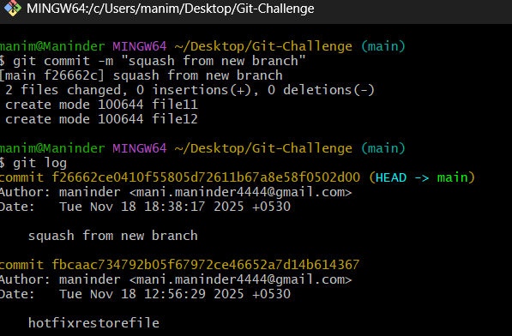

Implementation ( Rebase merge):

Checkout to the branch named newbranch and created file33 and file44, stagged and commit the files in the branch.
Checkout to the main branch and execute the command ‘git rebase newbranch”.
The commit history shows the commits of the newbranch on the top of the main branch commits.
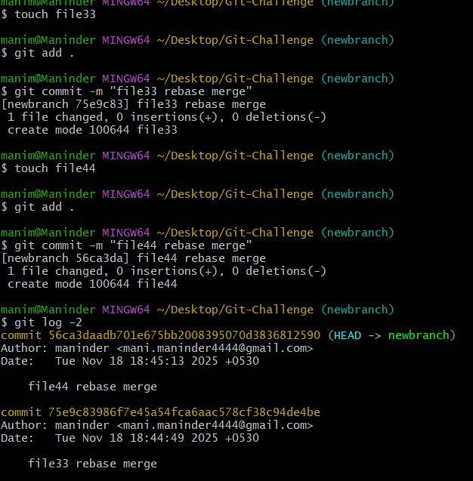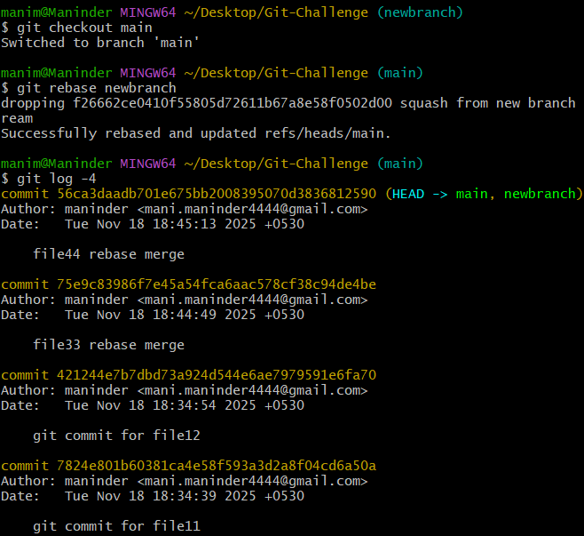

- Fork & Pull Request Workflow
  - Fork a repo, make a change, and submit a pull request to the original
Made a fork of the random user and made the repo out of that fork
Cloned the forked repository to the local repo and created the new branch named ‘release’ checkedout to the release branch and changed the contents of the file1 and file2, stagged and committed
Used command ‘git push origin release’ to upload and create release branch in the github repo
Initiated pull request from the main branch from the release branch
  - 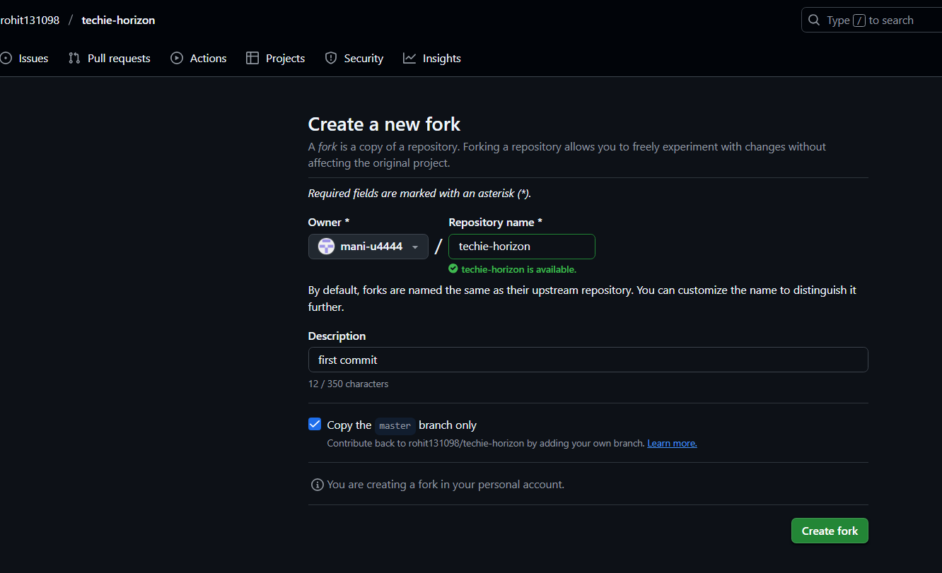
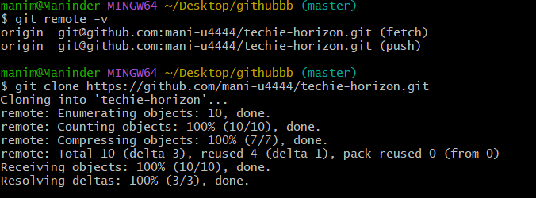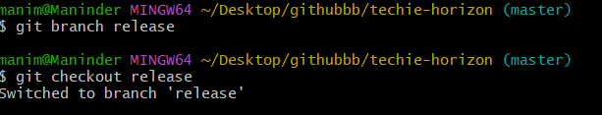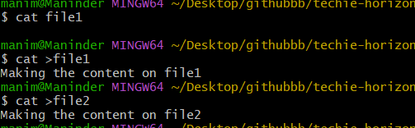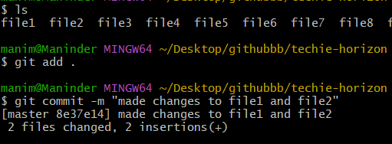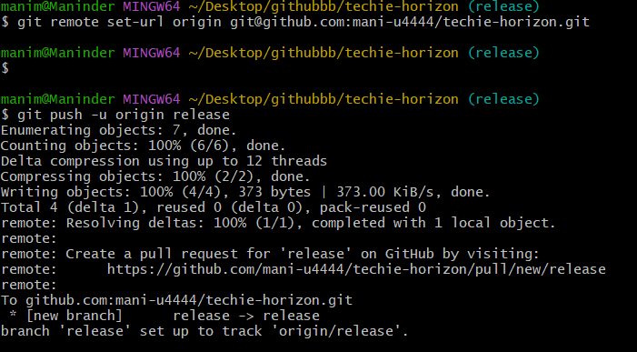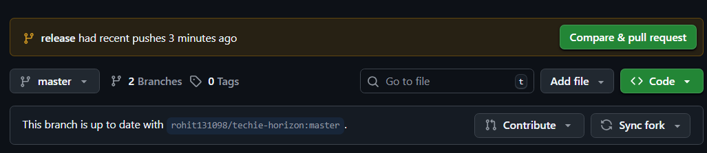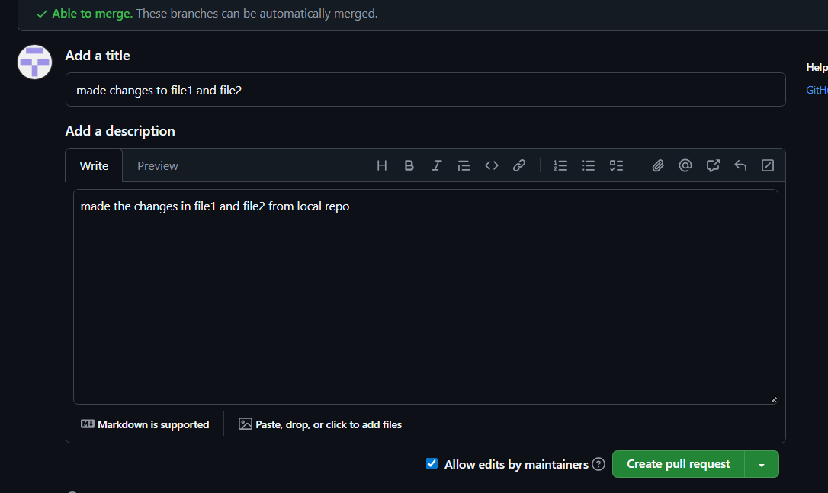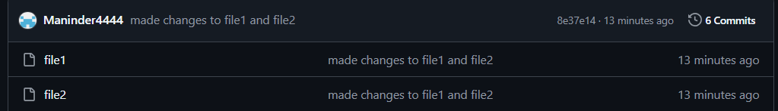

- Recover Lost Commit
  - Commit something, reset hard, and then recover it using git reflog.

Commands used:
touch file11
cat > file11
This content is to test the hard reset after git reflog
git add .
git commit -m "file for reflog"
git reset --hard HEAD~1
git log -1
git reflog
git cherry-pick <b869bb7-commitid returned during reflog exec>

created file11 and input the file with content, stagged and committed the file11
executed ‘git reset –hard HEAD~1
checked the commit history and found that file11 commit is lost and executed ‘git reflog’ it had returned the commit id of the file11
executed ‘git cherry-pick <commitid of file11> and recovered the commit as shown in the commit history.

